Database Unified Onboarding - Physical Data Model Diagram and Data Dictionary

Awais Sultan
12/15/2019

USB_UO
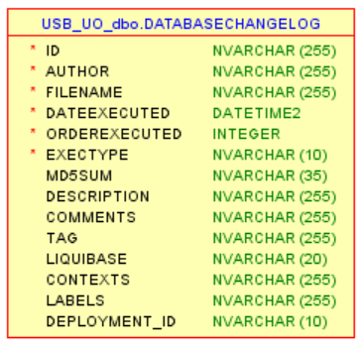
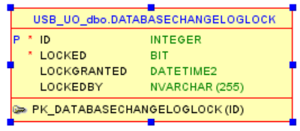

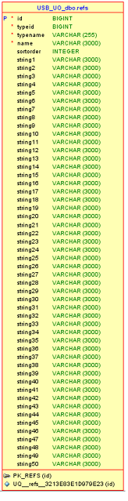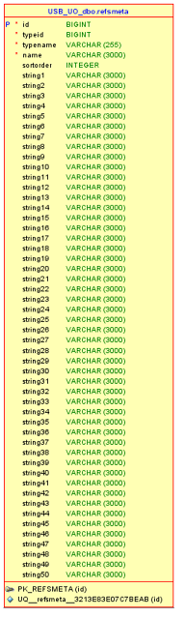
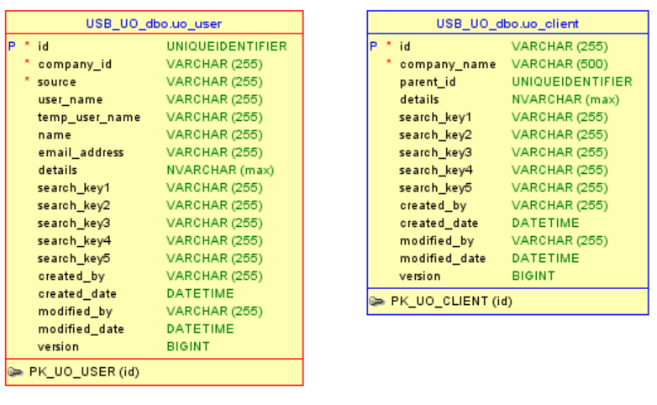

JSON Objects
Json objects for those tables that will be replaced with a little varying corresponding JSON representation in NO-SQL DB like Cassandra. Rest of the tables will be exactly as-is 1 to 1 conversion.
USB_UO_dbo.uo_client

Search Keys:
Search by: companyName
Search by: id

Structure:
{
"createdBy": "Onboarding",
"createdDate": "2020-11-11T08:00:03.377Z",
"modifiedBy": "Onboarding",
"modifiedDate": "2020-12-11T16:59:15.637Z",
"id": "0015C00000QIJECQA5",
"companyName": "ABC Enterprises ABC Enterprises1 ABC Enterprises2 ABC Enterprises 3",
"searchKey1": "",
"searchKey2": "",
"searchKey3": "",
"searchKey4": "",
"searchKey5": "",
"version": 59,
"billingAddress": { (data type as billing address, see if billingAddress.city will work in cluster key)
"zip": "554545",
"state": "MN",
"country": "US",
"city": "Richfield",
"billingStreet": "2 Meridian Xing"
}
billingAddress_city:””
billingAddress_state
}

USB_UO_dbo.uo_user

Search Keys:
Search by: Email address
Search by: username
Search by: tempUserName
Search by: source
Search by: name
Structure:
{
"createdBy": "Onboarding",
"createdDate": "2020-11-16T04:03:07.237Z",
"modifiedBy": "Onboarding",
"modifiedDate": "2020-11-25T07:47:31.337Z",
"id": "4bfc50e8-6465-4aff-bafd-0fe91b46b016",
"source": "salesforce",
"userName": "",
"tempUserName": "",
"name": "Kishore Pothuri",
"emailAddress": "kishore.pothuri@usbank.com",
"searchKey1": "",
"searchKey2": "",
"searchKey3": "",
"searchKey4": "",
"searchKey5": "",
"version": 4,
"companyId": "0015C00000VglZQQAZ",
"phoneNumber": "6129738330",
"pivotStatus": "Unauthorized"
}

USB_FSAO

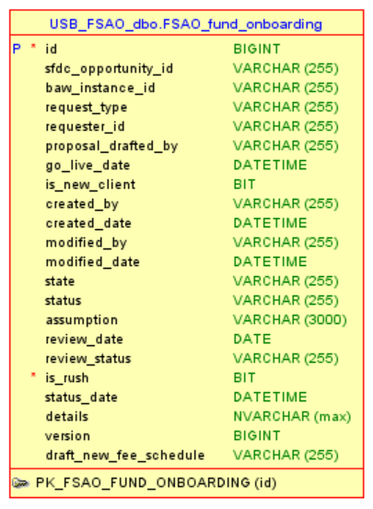

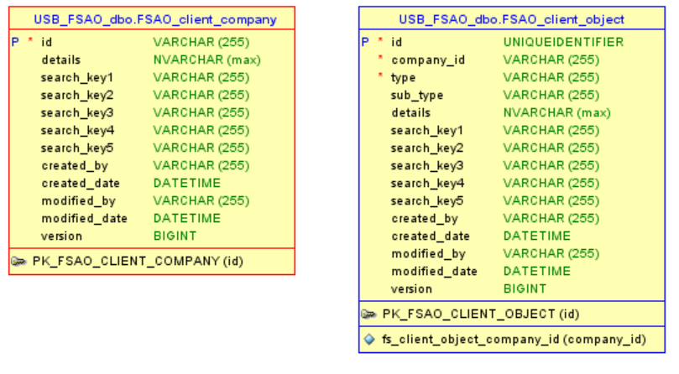
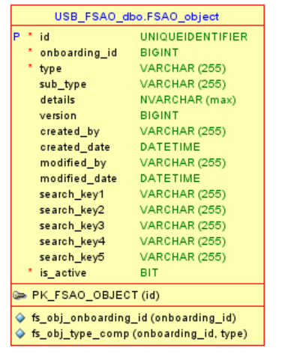

JSON Objects
Json objects for those tables that will be replaced with a little varying corresponding JSON representation in NO-SQL DB like Cassandra. Rest of the tables will be exactly as-is 1 to 1 conversion.
USB_FSAO_dbo.<Object>
<Sub-Object>

Client Object will have different objects, but right now it only has User object

Objects table wil have Funds, checklist item, service team

Pivot will pass user id and for that id, UO will get UUId from its own user table and pass it on to FSAO application and it will return tasks. The user information and client(Company) information already exist in UO and will be created through its own (UO) create profile pages.

UO (user id) to get tasks from FSAO

FSAO will go to client object table to get onboarding access for user id (like what onb ids it has access to). User object in client object table will be used. Will loop through list to get task list for each onboarding, check list item object will have task information for onb/us + the master task list info is in ref table and both lists will be combined. Tasks will be returned. Company information will be already in UO database.

IN tasks list some tasks related to Funds, for those tasks we get fund id from Fund object.

When you click on the task you go to details page, on he details page , we make two calls, one is service team contact call (will use service team object) and get document list call (get from FileNet).

For one specific task like verify fund information. For that tasks we get Fund details from Fund object.

Cassandra team to contact:

Developers will only access the POC environment.
From POC create spread sheet called data model, to create tables in Dev. EDAI team will create tables for you (Biju, Tom is for data modeling).

